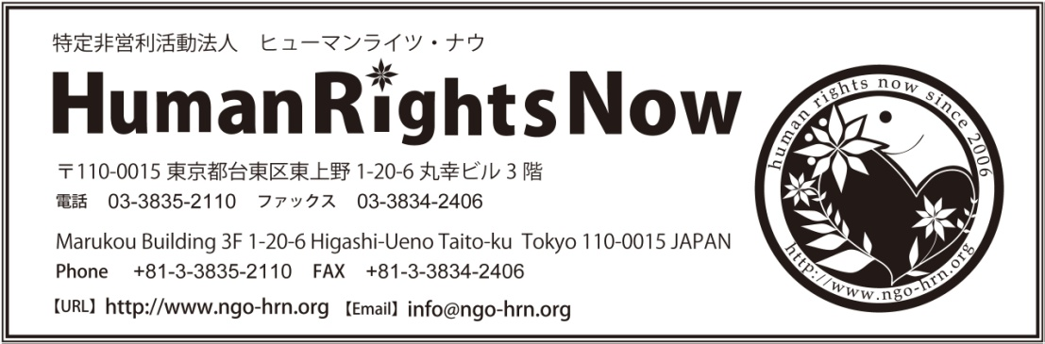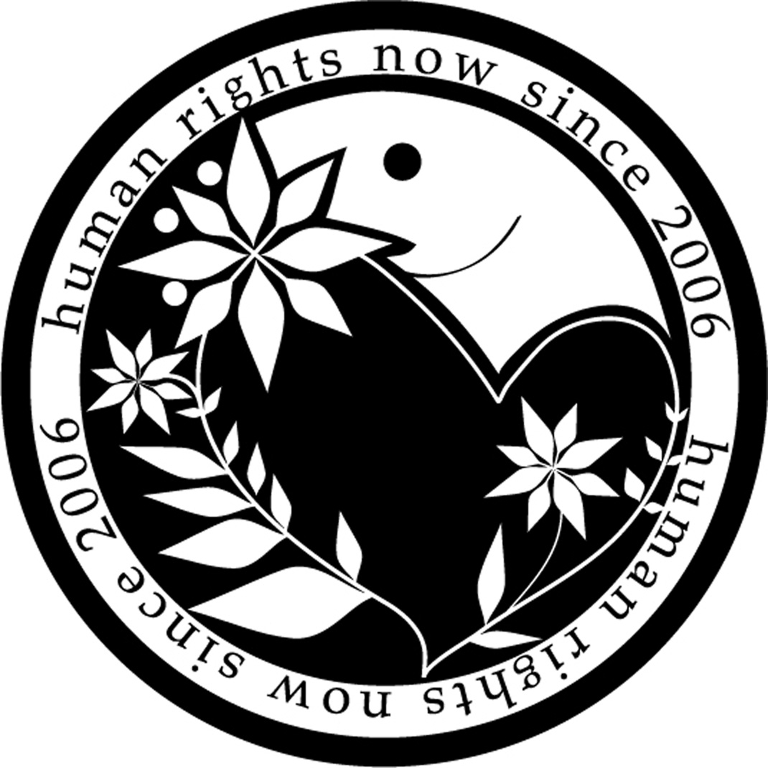

http://hrn.or.jp/eng　info@hrn.or.jp

7F Creative One Akihabara Bldg. 5-3-4 Ueno

Taitou-ku, Tokyo 110-0005 Japan

Phone: +81-3-3835-2110 Fax: +81-3-03-3834-1025

**April 16, 2015**

**Immediate release**

**Cambodia: Labour Exploitation in the Garment Industry**

**-Responsibilities of the Cambodian Government and International Brand Companies**

1. Human Rights Now (HRN), a Tokyo-based international human rights NGO conducted a fact finding mission in Cambodia to investigate the situation surrounding the labour rights and working environments in garment factories, during the period from February 8th to February 12th 2015. In South East Asia, there are significant numbers of garment factories supplying clothes and shoes to international brands, including Japanese brand companies. However, these international brands sometimes prioritize low priced goods to be competitive in the market, causing violations of labour rights.

In Cambodia, there are over a half million people working in garment manufacturing, and the country’s exports are dominated by 80% in garments. The garment industry in Cambodia supplies major international companies such as Gap, Nike, H&M and UNIQLO. Cambodian workers which belong to subcontracted companies are paid little. Garment workers, 90% of whom are women, are severely exploited.

A protest in Babette District that started in December 2013 called for an increase to the minimum wage from $80 per month to $160. Since January 2014, the government and security forces have brutally cracked down on protests in Phnom Penh. At least four people died, 39 people were injured, and many participants were detained. In the response to the heightened criticism among the international community, the Cambodian government implemented a series of labour policies, including increasing the minimum wage.

However, despite conducting only a short-term investigation, Human Rights Now found that the situation surrounding labour rights in Cambodia remains very serious.

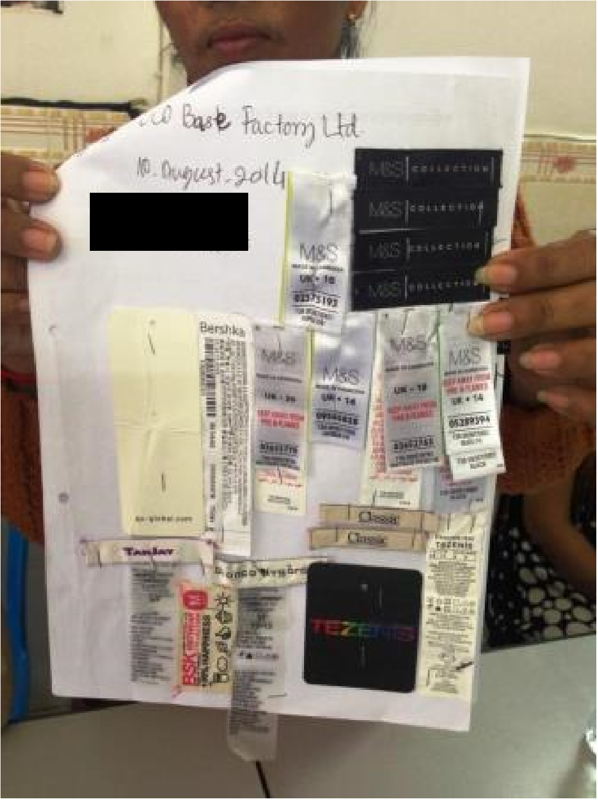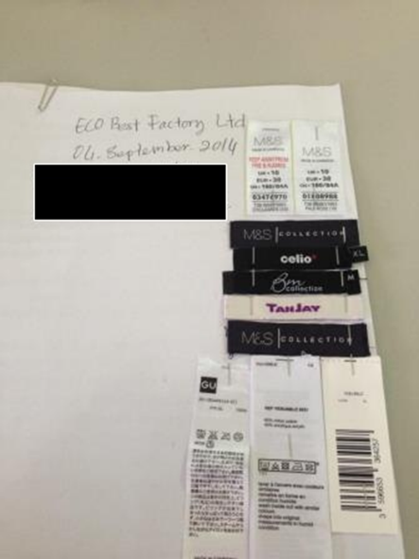

The product tag shown by the workers of ECO Base (Personal information has been redacted.)

2. Minimum Wage

On December 31, 2013, the Cambodian government decided to raise the minimum wage to $100 per month for workers in the garment and shoe industry, and raised it further to $128 in January 2015.

However, this increase hardly covers the living expenses for workers living in the capital, and these workers end up working overtime. The labour unions are demanding a decent living wage of more than $160 per month, and NGOs working on labour rights are calling for international brands to sign a Fair Wage Agreement to ensure a fair payment to workers.

For workers in areas other than garment and shoe factories, minimum wages have not yet been set. Thus, workers are still placed in a vulnerable situation by labour exploitation.

3. Working Situations according to Interviews

After careful selection, Human Rights Now conducted comprehensive interviews with workers working in four factories, three in Kandal City and one in Phnom Penh, on the working conditions in the factories, and confirmed labour contracts, identification documents, brand tags, and relevant judicial materials.

The box below lists the brands and factories examined, their numbers of employees, and persons interviewed.

|  |
| --- |
| 1) Full Fortune Knitting Ltd:  500 employees in peak season. About 100 employees have been recently dismissed or refused to renew their contracts. Main Brands: GU (Japanese). HRN interviewed a young female worker in her 20s.  2) ECO Base Factory Ltd:  550 workers in peak season. About 100 workers have been recently dismissed or refused to renew their contracts. Main brands include: GU (Japanese), M&S (British), Celio (French), Tanjay Bianca Nygard (Canadian), etc. HRN interviewed a female worker in her 40s.  3) Zhong Yin (Cambodia) B Textile Co. Ltd:  Over 1000 workers. A number of workers have been recently dismissed or refused to renew their contracts, but a few more have been hired again later. Main Brands: H&M (Swedish), UNIQLO (Japanese). HRN interviewed with a male worker in his 20s.  4) Vanco Industrial Company Limited:  The number of workers is unknown. Main Brands: H&M (Swedish). Four female workers in their 20s were interviewed.  * The primary concerns were extracted from interviews which are indicated in (1) to (3) above. |

As a result of the interviews, HRN found the following labour rights violations.

(a) Illegal and Cruelly Prolonged Overtime Work

According to the workers which HRN interviewed, they have been working overtime beyond the labour rights standards.

Under Cambodian law, one day’s overtime hours are limited to a maximum of two hours. However, in the garment factories which HRN examined, workers are forced to work overtime hours exceeding the limit without payment. ,

According to the two female workers at both the **Full Fortune Knitting Ltd. (hereinafter, Full Fortune) and ECO Base Factory Ltd. (hereinafter ECO Base)**, their formal working hours are from 7 am to 4:30 pm; however, they stated that overtime work until 9 pm is very common.

Furthermore, at the same factories, male and female workers are expected to work consecutive 24 hour shifts. It is obviously compulsion of overtime work against the laws. In spite of the great amount of overtime hours, however, a worker's monthly payment never exceeds $200 per month. Since workers do not receive detailed payment slips, the calculation basis for the wages is unknown for workers.

At the factories, workers are instructed to punch out at 6:00 pm; thus, overtime work after 6:00 pm is not paid. These workers are only getting paid $5 after finishing 24 hour work shifts.

Cambodia Labour Law states that the legal working hours are limited to eight hours per day. The Law states that the overtime hours shall be paid at a rate 50% higher than normal hours, and the rate of increase shall be 100% at night or during weekly time off. However, the worker at ECO Base testified that "Previously, we had been paid double the wage of normal hours for overtime work at night, but management recently cut down payment overtime hours to only 130%, that is, only an extra 30% over the normal wage. Furthermore, she reported that she has witnessed three colleagues pass out during the harsh night shift. According to her, despite the workers have demanded that the employees be provided with a doctor to stay at least during the overtime hours, the factory management does not respond to their demand.

The male worker at **Zhong Yin (Cambodia) B Textile Co. Ltd.** (hereinafter Zhong Yin) was also asked to work overtime almost all days, including 24 consecutive hours work, even though regulations set work hours from 7:00 am to 4:00 pm. However, he reported that he was never paid for overtime hours after 6 pm. After 24 hours of overtime shifts, workers were only handed five dollars in cash. This seems to be very similar to the practices employed at ECO Base and Full Fortune.

According to the workers, although they are often asked to work overtime, including harsh 24 hour overtime shifts, it is actually impossible for them to refuse the request. The worker from ECO Base stated that overtime work was unavoidable due to the nature of the time-card system. The worker from Zhong Yin testified that **“I must work overtime, otherwise my contact would not be renewed. I must obey.”**

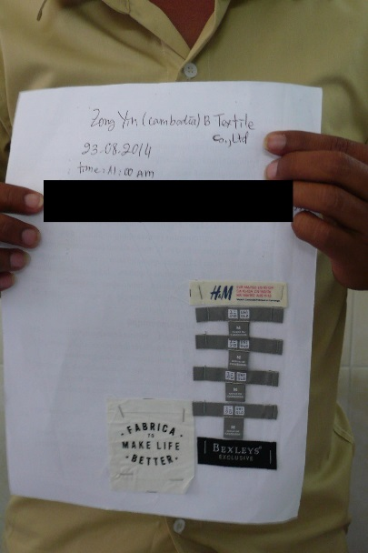 Product tags presented by the employee at Zhong Yin (Personal information has been redacted.)

(b)　“Disposable” Workers

Two workers that HRN interviewed had the renewal of their contracts refused, while one was dismissed.

The workers at Full Fortune, ECO Base and Zhong Yin had their contract renewals carried out every three months. However, the factories refused to renew their contracts before exceeding two years period. The workers testified that factories justified the non-renewals for reasons of “the financial situation” or “lack of work” while they kept recruiting new workers.

Similarly, a few female workers at **Vanco Industrial Company Limited** voiced their vulnerable labour status with short-term contracts such as one or two months.

According to Article 67 of Cambodia's Labour Law, the labour contract for a specific duration cannot be for a period longer than two years, and when the length of employee’s service exceeds a period of two years, the contract becomes a labor contract of undetermined duration.

It is suspected that factories dispose workers before they reach a two year consecutive work term in order to avoid the legal obligation.

The short contract duration and continual refusal to renew contracts only makes workers more vulnerable. When employees desperately wish to keep their jobs, they have no freedom to refuse overtime work, despite their will not to do so. Also, they cannot raise their voices to improve working conditions, but suffer from poor and unfair working conditions and unpaid overtime work.

(c) Discriminatory Treatment of Labour Union Activities

Articles 12 and 270 of Cambodian Labour Law prohibit any discrimination over promotion or termination of employment based on workers’ membership of workers’ union or the exercise of union activities. However, the female worker in her 20s from Full Fortune claimed that she was dismissed and the possible reason was her membership and activities of workers’ union.

According to the worker, she participated to the union activities and negotiated with the management to improve female worker’s condition in accordance with the law, including implementation of a maternity leave system, and achieved numbers of improvement.

She stated that her labour contract has become a contract of undetermined duration since she had served for over two years; nevertheless, she was dismissed in September 2014 without any warning. Further, it was a dismissal during her pregnancy. According to her, nine female workers who participated to the union activities were also dismissed at the same time.

Similarly, workers from ECO Base and Zhong Yin claimed that they are also union members and it was the reason for management to of refuse contract renewal.

(d) Lack of the Protections for Female Workers

Many garment factory workers are female. Thus the protection of female workers and guarantee of their rights are important matters, such as allowances for maternity leave and provisions for periodic health check-ups. Cambodian Labour Law has provisions regarding maternity leave and other guarantees for female workers.

However, a female worker in her 20s was dismissed by Full Fortune during pregnancy.

She claimed, “If a pregnant female’s contract is a contract with specific duration, the labour contract may easily be terminated by the employer. If a female worker refuses overtime work or asks certain leaves, the renewal of the labour contract will be refused.” In addition, harsh and long overtime work as mentioned above obviously lacks a work-life balance and is harmful for women’s health. Under such circumstances it is impossible for female workers to maintain work with family responsibilities.

(e) Work-Environment Safety

There are alarming situations in occupational safety and environment among the garment factories examined. The worker of ECO Base testified that "the [factory’s] ceiling collapsed in 2014, and workers were injured by this accident. Even now the roof leaks when it rains." She claimed that “an iron sparks and some workers get injured sometimes.” She said that “I am very afraid of an accident because there is only one available exit at night and that is very far away from where I work,” and pointed out that “almost all instructions in the factory are in English but not in Khmer.”

The worker of Zhong Yin claimed that many workers pass out because the room temperature is extremely high without air conditioning. According to the worker, the workers do receive a mask to cover their mouths and noses from the detergent’s strong pungent odours in the laundry department. However, none of the workers are able to use the masks because the room temperature is too hot, making it very difficult to breathe with them on. Furthermore, workers are not equipped with goggles, but are forced to wear masks and goggles only when inspectors come to the factory.

Female workers at Vanco Industrial Company Limited testified that they have seen workers pass out due to the harsh work environment. Their dining area is very small and dusty, according to the workers.

(f) Lack of effective mechanism to redress labour rights violations

Despite the serious situation, worker’s rights violations are not sufficiently redressed. The Full Fortune’s female worker who was dismissed during pregnancy has filed a case before arbitration. However, her complaint was not admitted since the Arbitration Council applied Cambodia's civil code instead of the Labour Law even though the case is clearly a labour dispute. She is currently appealing the case.

4. Attacks on Labour Unions

According to the Coalition of Cambodian Apparel Workers' Democratic Union(C CAWDU), 6715 people were dismissed due to their active participation in Labour Unions in 2014, out of which 60 percent were female workers. After negotiations with labour unions, 4166 people were able to return to work, 55% of which were women. Unfortunately, 1000 cases remain unresolved, and there were many cases pending before the arbitration proceedings.

The Arbitration Council has operated with the support of the ILO, and it achieves fair dispute resolution sometimes. However, reaching such a fair resolution remains very difficult in the case of lawsuits.

5. Recommendations

As has been discussed throughout this statement, HRN found serious labour rights violations in several Cambodian garment factories, including low average salaries, forced and unlawful overtime work, long work durations that sometimes amount to mandatory 24 hour shifts, unpaid overtime work, manipulation of workers by inducing a fear of contract non-renewal, infringement of freedom of association, and lack of protection for female workers such as implementation of maternity leave.

These problems have been caused by the fact that Cambodian Labour Law has not yet sufficiently implemented in work settings; laws on short-term contract have been misused to dispose workers who speak up for inadequate treatment at workplaces; and lack of an effective mechanisms to redress the violations.

At the same time, attention should be given to the corporate responsibilities of international brand companies, given that the factories that HRN investigated are the suppliers to these brands.

As the UN *“Guiding*Principle*s on Business and Human Rights”* clearly states, business enterprises should carry out human rights due diligence to address their adverse human rights impact. When a business enterprise causes or may cause an adverse human rights impact, it should take the necessary steps to eliminate the violations.

The brand corporations highlighted throughout this investigation--including Fast Retailing (UNIQLO & GU), H&M, and M&S—should be active in remediation of any adverse human rights impact, through investigations, improved monitoring, disclosing the outcome of any investigations, etc.

HRN wish to make following recommendations to relevant actors,

***To the Cambodian Government:***

(1)To enhance supervision, to strengthen sanctions against Labour Law violations and to ensure the proper implementation of the law in order to ensure workers' rights, as stated in the Labour Law, in particular:

・To thoroughly enforce the statutory working hours and eliminate unlawful overtime work;

・To eliminate unpaid overtime work and pay for overtime hours that meets Labour Law standards;

・To consider effective sanctions for unlawful dismissals or refusals of contract renewals due to pregnancy or child birth;

・To require sanctions for discriminatory dismissals and refusals of contract renewals due to the exercised of union activities, while also establishing effective and speedy mechanism to protect workers from discrimination.

・To enhance capacity building and other forms of support to provide adequate operations of the Arbitration Council;

・To consider the revision of Labour Law in order to prevent abuse of rights to refuse renewal of labour contract for a specific duration;

(2) To conduct genuine dialogues with workers on raising wages in order to ensure the living wage. Furthermore, to establish the minimum wage for other production branches aside from garment and shoes industries.

***To Full Fortune Knitting Ltd, ECO Base Factory Ltd, and Zhong Yin (Cambodia) B Textile Co. Ltd***

(1) To immediately investigate the following issues claimed by workers and publish the findings, and to improve the identified issues:

-Illegal overtime work; unpaid overtime work;

-dismissal or refusal of contract renewals due to pregnancy, childbirth, membership of workers’ union, the exercise of union activities, refusal of overtime work, or/and asking for day offs; and -hazardous work environment.

(2) To ensure the rights of workers to establish union and to participate in union activities.

***To brands which have trade with the above factories, such as Fast retailing, H&M, and M&S :***

(1) To immediately investigate the following issues claimed by workers at supplier factories (including Full Fortune, ECO Base and Zhong Yin) and publish the findings.

-Illegal overtime work; unpaid overtime work;

-dismissal or refusal of contract renewals due to pregnancy, childbirth, membership of workers’ union, the exercise of union activities, refusal of overtime work, or/and asking for day offs; and -hazardous work environment.

(2) To conduct dialogues with suppliers over the identified problems, and support improvements of labour condition in supplier factories.

To all international brands that have supply factories in Cambodia:

(1) To facilitate all suppliers to ensure full compliance with international human rights, labour standards and Cambodian domestic Labour Law and regulations, and to take a proactive role in the elimination of violations of workers' rights.