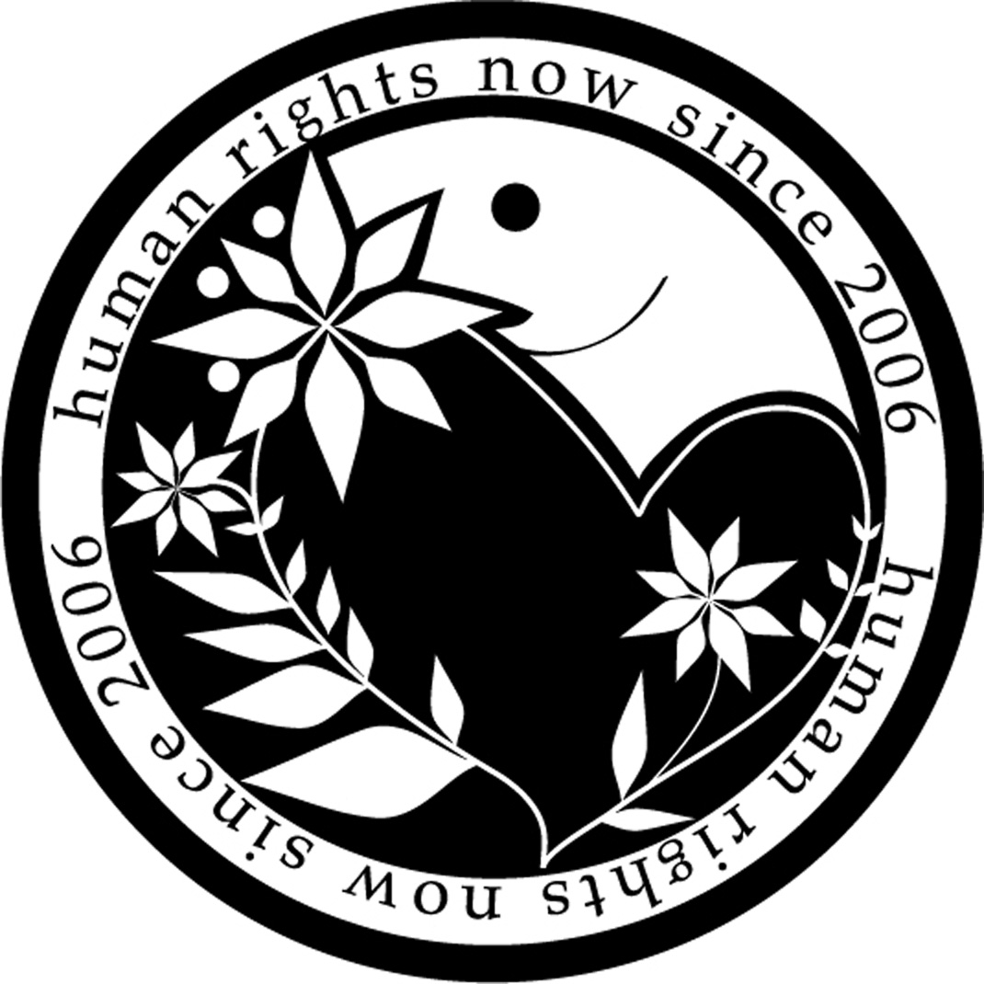
Human Rights Now

Oral statement on agenda Item 3 ID
UN Human Rights Council 25th Session,
Geneva, 3 -28 March 2014 Speaker: Ms. Yuriko Moto

Human Rights Situation in Myanmar

Thank you Mr. President,

Human Rights Now welcomes the considerable improvement of the human rights situation in Myanmar in recent years. However, the restrictions on the freedom of press is still of an alarming level.

Censorship is still in practice, as the case of Khine Khine Aye Cho, known as Ma Khine, shows. He was unjustifiably sentenced to 3 months imprisonment on charges of defamation, trespassing and the use abusive language. Another five journalists were arrested and detained without bail for reporting the existence of a chemical weapons factory, which was a state secret. Although the government released a significant number of political prisoners and promised to drop charges against activists facing trials , at least 33 political prisoners are still detained with 148 awaiting sentencing. Activists claim that the authorities continue to prosecute those deemed dissidents.

Human rights violations cause by foreign investment projects under the pretext of “development”, including Thilawa Special Economic Zone Project, which is sponsored by the Japanese government and JICA, are of another serious concern. The Myitsone Dam project, for instance, has provoked massive public outcry over the potential widespread flooding and deforestation in addition to the displacement of 10,000 ethnic Kachin villagers. In most cases, local residents are forced to move to a relation site where survival is difficult with little compensation. Farmers, whose land has been confiscated for a controversial copper mine project, claim that a sulfuric acid plant that purifies copper from the mine is responsible for local illnesses.

We call upon the Council to continue to address the on-going human rights violations in Myanmar. We urge the government of Myanmar and its development partners to establish and implement policy guidelines in line with the principles of the United Nations Guiding Principles on Business and Human Rights, so as to prevent further human rights violations and to provide appropriate remedies and reparations to those affected.

Thank you.

Human Rights Now (HRN) is Tokyo-based international human rights NGO
The Irrawaddy, December 23, 2013: http://www.irrawaddy.org/burma/prison-term-reporter-leads-outcry-media-freedom.html
The Irrawaddy, February 2, 2014: http://www.irrawaddy.org/burma/journalists-detained-reporting-alleged-burmese-chemical-weapons-factory.html
The Irrawaddy, December 31, 2013, http://www.irrawaddy.org/burma/burma-pardons-political-offenders.html
News 24, December 11, 2013, http://www.news24.com/World/News/Myanmar-frees-44-political-prisoners-20131211
Strategy World, December 24, 2013: http://www.strategypage.com/qnd/myanmar/articles/20131224.aspx.
Id.
Mizzima, December 10, 2013: http://www.mizzima.com/mizzima-news/environment/item/10721-health-survey-planned-at-village-near-copper-mine-acid-plant; The Irrawaddy, December 12, 2013: http://www.irrawaddy.org/burma/near-letpadaung-factory-pollution-raises-health-fears.html

