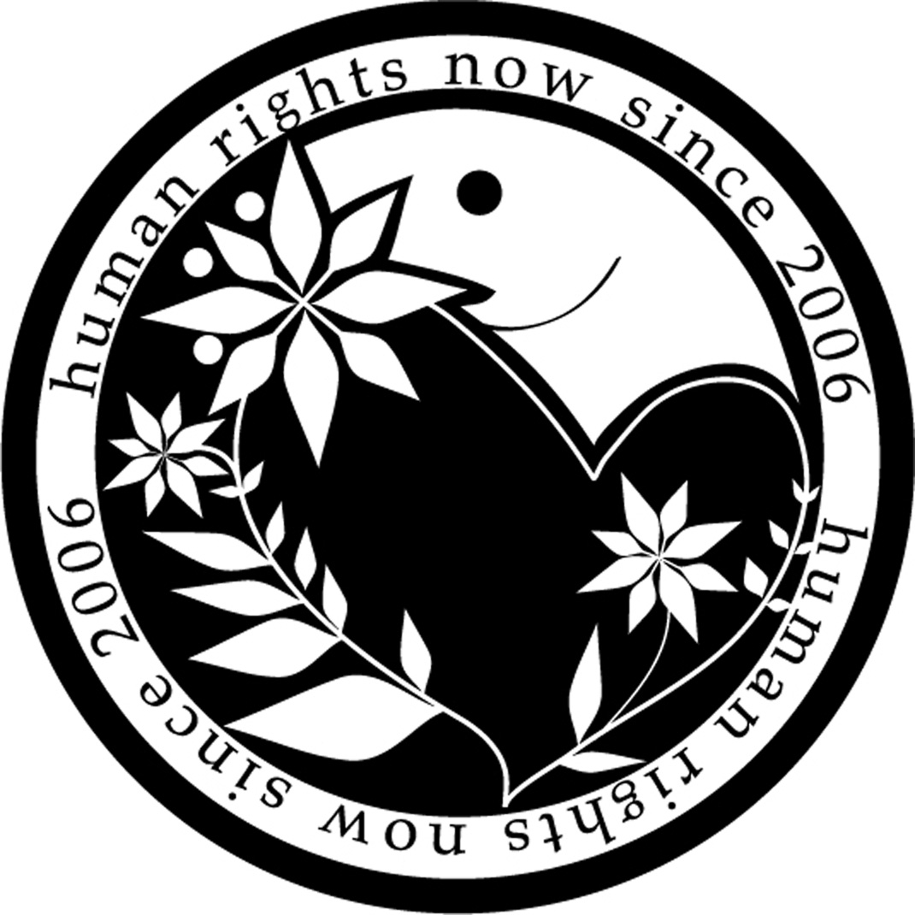**Human Rights Now**

**Oral statement on agenda Item 3 ID**

**UN Human Rights Council 25th  Session,**

**Geneva, 3 -28 March 2014 Speaker: Ms. Yuriko Moto**

**The Right of the People in Fukushima to Health Still Affected and Least Protected**

Thank you Mr. President,

Human Rights Now[1] expresses its grave concern over the human rights situation of the people affected by nuclear disaster at the Fukushima-Dai-ichi Nuclear Power Station. Three years have passed since the accident. Yet the government’s effort has not been sufficient or effective to protect people’s right to health.

In May 2013, following his visit to Japan, the UN Special Rapporteur Anand Grover produced a report, in which he made recommendations to the government of Japan. It emphasized the need of substantial reforms in policies and measures in order to protect the right of the affected people in Fukushima to health. Regretfully his recommendations have so far been ignored. For example, the government still keeps the exposure level of 20mSv/year for determining the area to be evacuated. It is 20 times higher than the recognized international standard. As a result, people in Fukushima, particularly the most vulnerable groups such as children and women are still living in highly contaminated areas. The government now plans to remove some areas from the so-called designated evacuation zones. This decision will automatically bring about the termination of the monthly compensation payment by TEPCO. A number of people who will find themselves in the situation that they have to decide either to return to the contaminated areas or to stay in the temporary shelters with very limited financial support. Moreover, the government has been propagating a myth that “there is no evidence of physical harm caused by low level radiation below 100mSv/year”. Yet, all the relevant policies have been based on this unscientific belief without hearing the voices of citizens.

Furthermore, health monitoring after the accident remains extremely insufficient. The government has not conducted any health monitoring of affected people outside the so-called evacuation zones, except for children’s thyroid cancer in limited areas. Although 75 cases of thyroid cancer has alreadz been found in children, the government refuses to conduct further examination. The Special Rapporteur recommended to expand the health survey to the residents in “all affected areas with radiation exposure higher than 1mSv/year”[2] and recommended a comprehensive, long term health survey. He also expressed his grave concern about the adverse effect of radiation on the workers engaged in decontamination project at the Power Plant, and recommended the monitoring of all the workers’ health condition. However, none of these recommendations has been given considerations.

It is crucial that all the policies to be based on the rights-based-approach and give the highest priority to the protection of its citizens from further health hazard caused by continuing exposure to radiation . Mr. President, nuclear hazards expand world-wide. We call on the Human Rights Council to act immediately on this important issue.

Thank you.

1. International human rights NGO based in Tokyo with ECOSOC special consultative status. <http://www.hrn.or.jp/eng>
2. A/HRC/23/41/Add.3